Annular Cross Sections

Definition
# Source: AI Source: Provided by: [Data Path: Persons Table -> ID Column: 1, Name_En Column: Motasem Essam] -> From: [ChatGPT] on [7/25/2026]
An Annular Cross Section is a two-dimensional ring-shaped region formed when a plane intersects a three-dimensional solid and the resulting section lies between two concentric circles.
It consists of:
- An Outer Circle, which defines the external boundary.
- An Inner Circle, which defines the boundary of the central hole.
- An Annular Region, which is the area between the two circles.
The annular region is also called an Annulus. It commonly occurs when cutting hollow cylinders, pipes, and toruses with suitable planes.

Geometric Representation
# Source: AI Source: Provided by: [Data Path: Persons Table -> ID Column: 1, Name_En Column: Motasem Essam] -> From: [ChatGPT] on [7/25/2026]
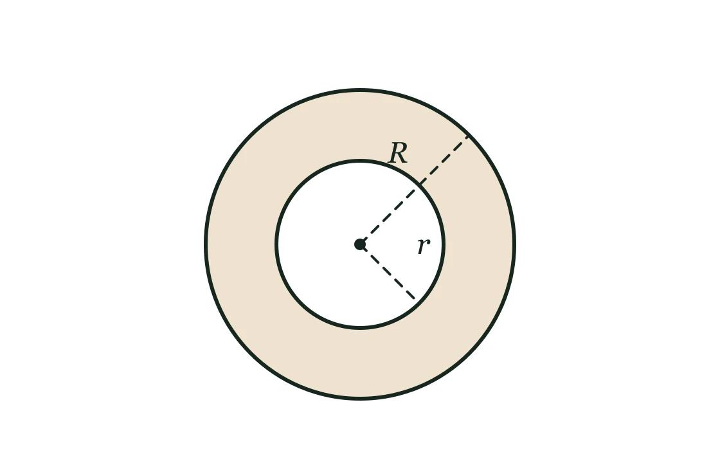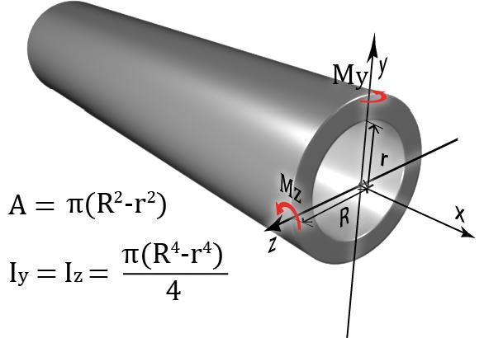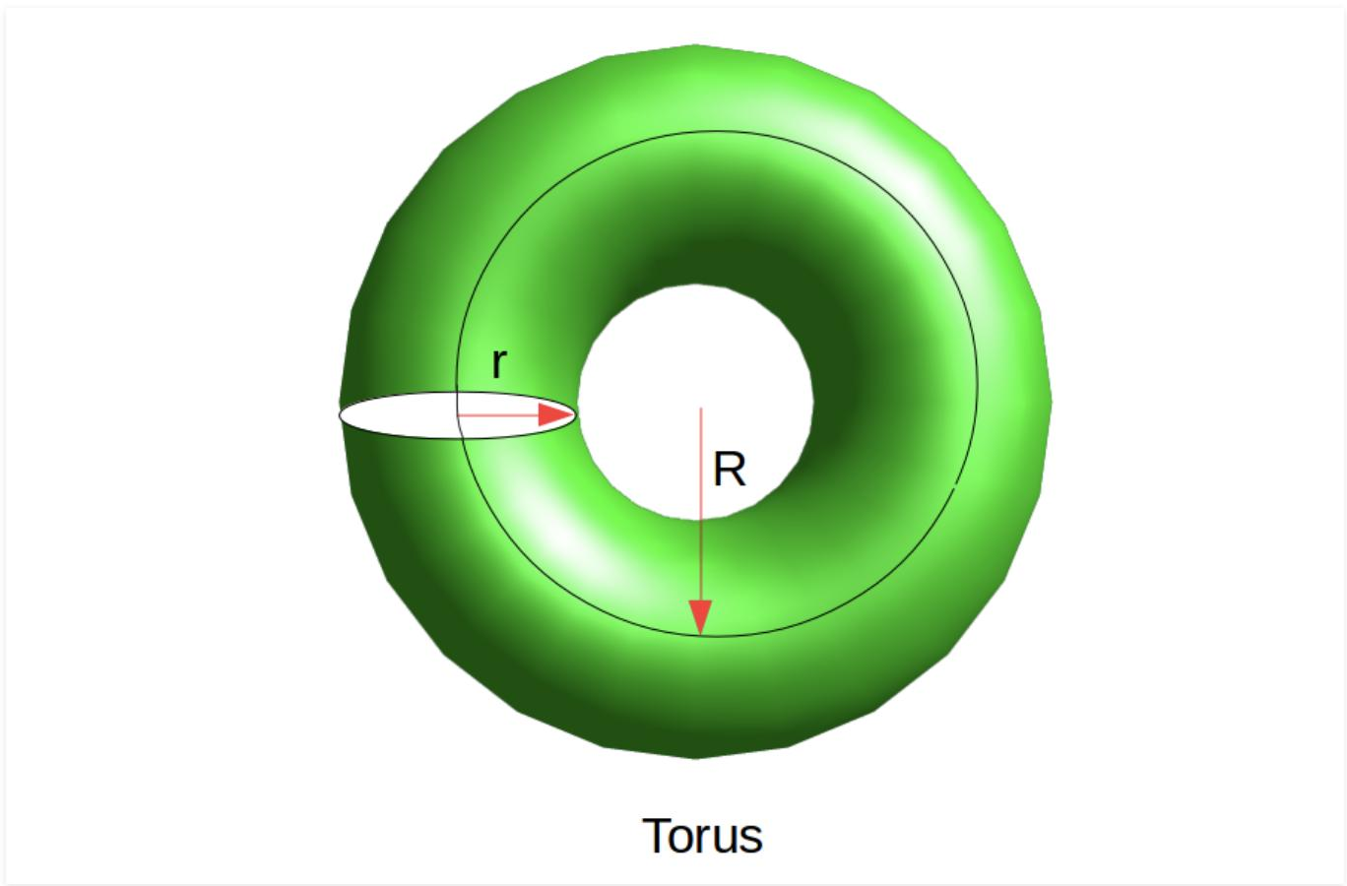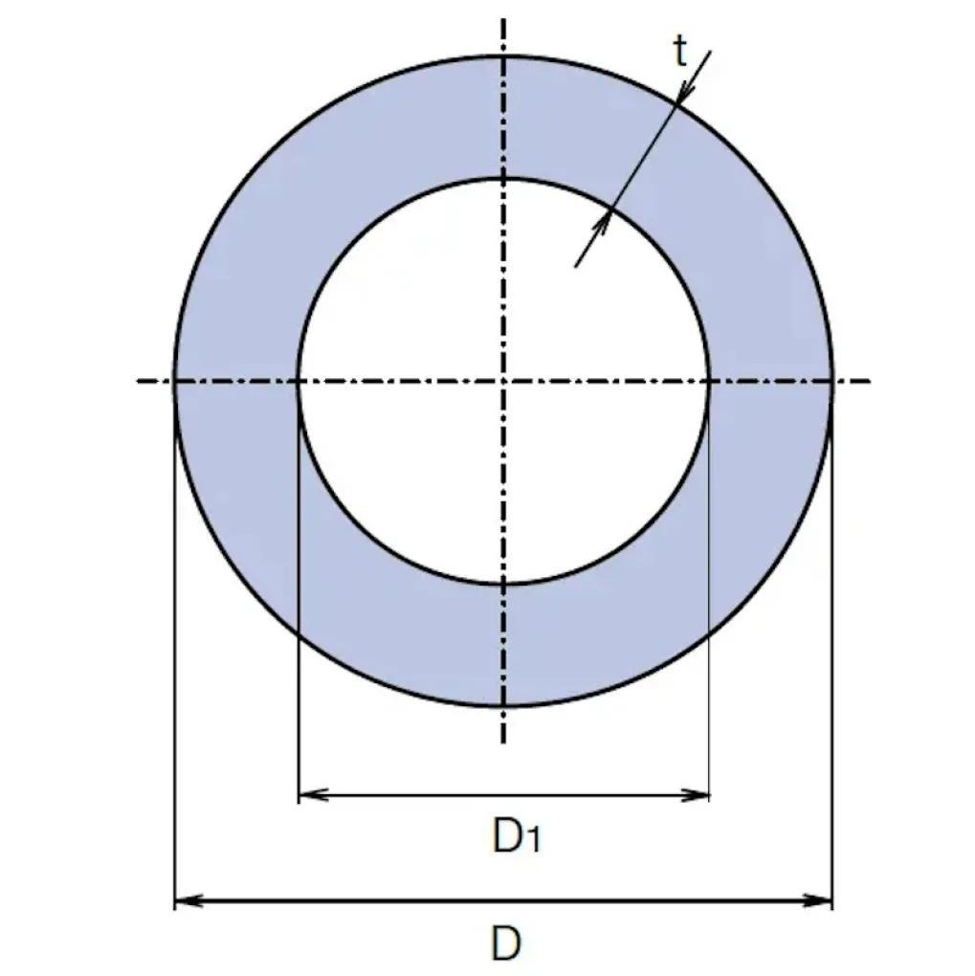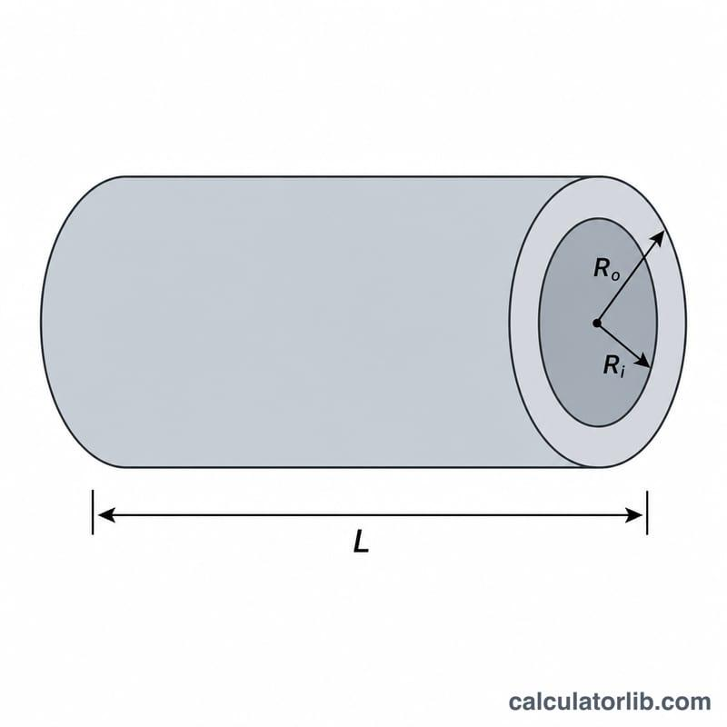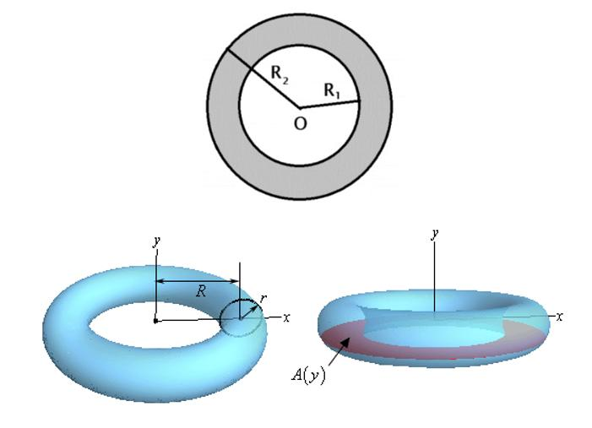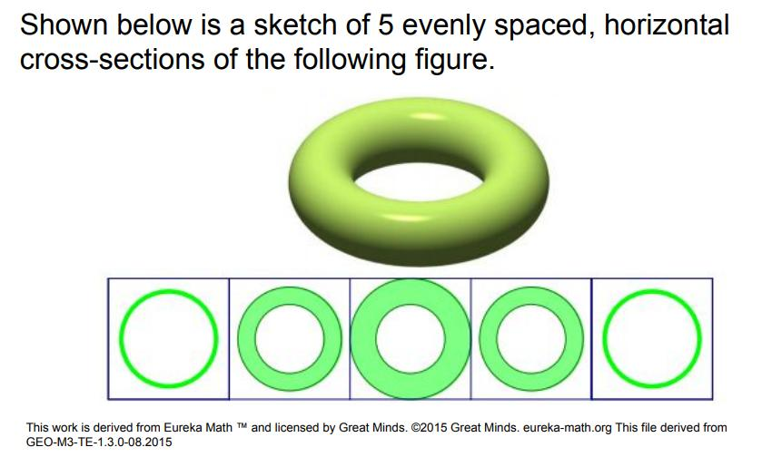

Geometric Structure
# Source: AI Source: Provided by: [Data Path: Persons Table -> ID Column: 1, Name_En Column: Motasem Essam] -> From: [ChatGPT] on [7/25/2026]
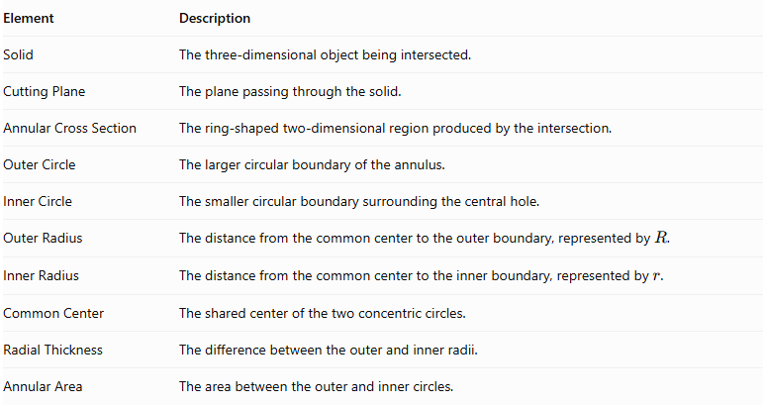
Element | Description
Solid | The three-dimensional object being intersected.
Cutting Plane | The plane passing through the solid.
Annular Cross Section | The ring-shaped two-dimensional region produced by the intersection.
Outer Circle | The larger circular boundary of the annulus.
Inner Circle | The smaller circular boundary surrounding the central hole.
Outer Radius | The distance from the common center to the outer boundary, represented by $R$.
Inner Radius | The distance from the common center to the inner boundary, represented by $r$.
Common Center | The shared center of the two concentric circles.
Radial Thickness | The difference between the outer and inner radii.
Annular Area | The area between the outer and inner circles.

Main Characteristics
# Source: AI Source: Provided by: [Data Path: Persons Table -> ID Column: 1, Name_En Column: Motasem Essam] -> From: [ChatGPT] on [7/25/2026]
- The cross section has a ring-shaped appearance.
- It is bounded by two concentric circles.
- The outer radius is greater than the inner radius.
- The central region is a hole and is not included in the annular area.
- Both circles share the same center.
- Its area is calculated by subtracting the inner circular area from the outer circular area.
- Its thickness is measured radially, from the inner boundary to the outer boundary.
- It can be produced by intersecting hollow or ring-shaped solids with suitable planes.

Types of Annular Cross Sections

According to Radial Thickness

A. Uniform Annular Cross Section
# Source: AI Source: Provided by: [Data Path: Persons Table -> ID Column: 1, Name_En Column: Motasem Essam] -> From: [ChatGPT] on [7/25/2026]
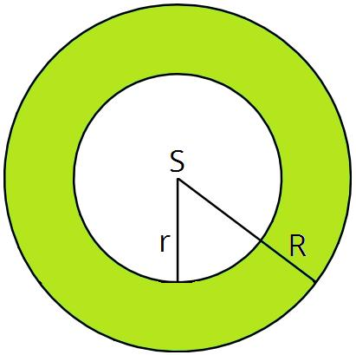
A uniform annular cross section has a constant radial thickness between its inner and outer circular boundaries.
$$t=R-r$$
Where:
- $t$ = radial thickness.
- $R$ = outer radius.
- $r$ = inner radius.

B. Variable Annular Cross Section
# Source: AI Source: Provided by: [Data Path: Persons Table -> ID Column: 1, Name_En Column: Motasem Essam] -> From: [ChatGPT] on [7/25/2026]
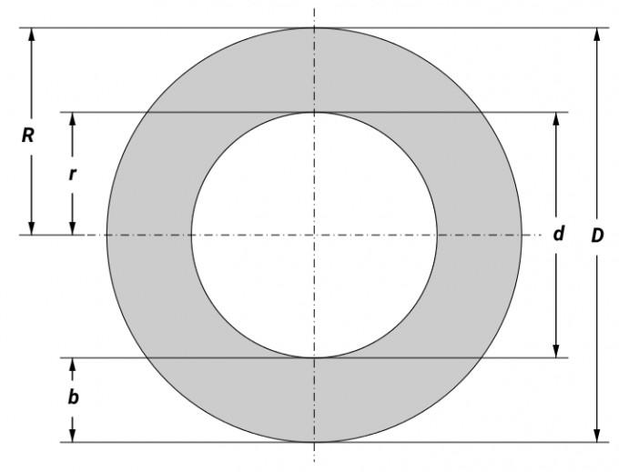
A variable annular cross section describes a ring-shaped region whose radial thickness changes around its boundary.
Note: A true annulus bounded by two concentric circles always has uniform radial thickness. Variable-thickness ring-shaped sections are more general shapes and should not be classified as strict annuli.

According to the Solid Producing the Section

A. Hollow Cylinder Annular Cross Section
# Source: AI Source: Provided by: [Data Path: Persons Table -> ID Column: 1, Name_En Column: Motasem Essam] -> From: [ChatGPT] on [7/25/2026]
A hollow cylinder produces an annular cross section when intersected by a plane perpendicular to its axis.
Characteristics:
- The outer circle represents the external cylindrical surface.
- The inner circle represents the internal hollow surface.
- The two radii remain constant along a uniform hollow cylinder.

B. Torus Annular Cross Section
# Source: AI Source: Provided by: [Data Path: Persons Table -> ID Column: 1, Name_En Column: Motasem Essam] -> From: [ChatGPT] on [7/25/2026]
A ring torus produces an annular cross section when intersected by a horizontal plane passing through its central plane of symmetry.
- The section has two concentric circular boundaries.
- The outer radius is the sum of the major and minor radii.
- The inner radius is the difference between the major and minor radii.

C. Hollow Circular Pipe Cross Section
# Source: AI Source: Provided by: [Data Path: Persons Table -> ID Column: 1, Name_En Column: Motasem Essam] -> From: [ChatGPT] on [7/25/2026]
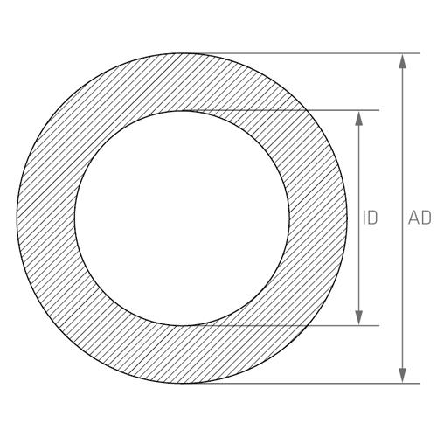
A hollow circular pipe produces an annular cross section when cut perpendicular to its longitudinal axis.
- The external boundary represents the outside of the pipe.
- The internal boundary represents the inside of the pipe.
- The annular area represents the material forming the pipe wall.

Examples According to Solid Type

Hollow Cylinder
# Source: AI Source: Provided by: [Data Path: Persons Table -> ID Column: 1, Name_En Column: Motasem Essam] -> From: [ChatGPT] on [7/25/2026]
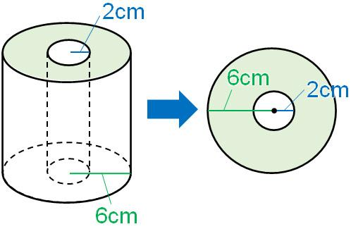
A hollow cylinder has an outer cylindrical surface and an inner cylindrical surface.
When a plane perpendicular to its axis intersects the solid:
- The outer cylindrical surface produces the outer circle.
- The inner cylindrical surface produces the inner circle.
- The material between the two circles forms the annular cross section.

Ring Torus
# Source: AI Source: Provided by: [Data Path: Persons Table -> ID Column: 1, Name_En Column: Motasem Essam] -> From: [ChatGPT] on [7/25/2026]
A ring torus is a solid generated by revolving a circle around an external coplanar axis that does not intersect the circle.
A horizontal plane passing through its central plane produces an annulus.
Let:
- $R$ = major radius of the torus.
- $r$ = minor radius of the torus.
Then:
$$R_{\text{outer}}=R+r$$
$$R_{\text{inner}}=R-r$$
The resulting section is an annulus when $R>r$.

Hollow Circular Pipe
# Source: AI Source: Provided by: [Data Path: Persons Table -> ID Column: 1, Name_En Column: Motasem Essam] -> From: [ChatGPT] on [7/25/2026]
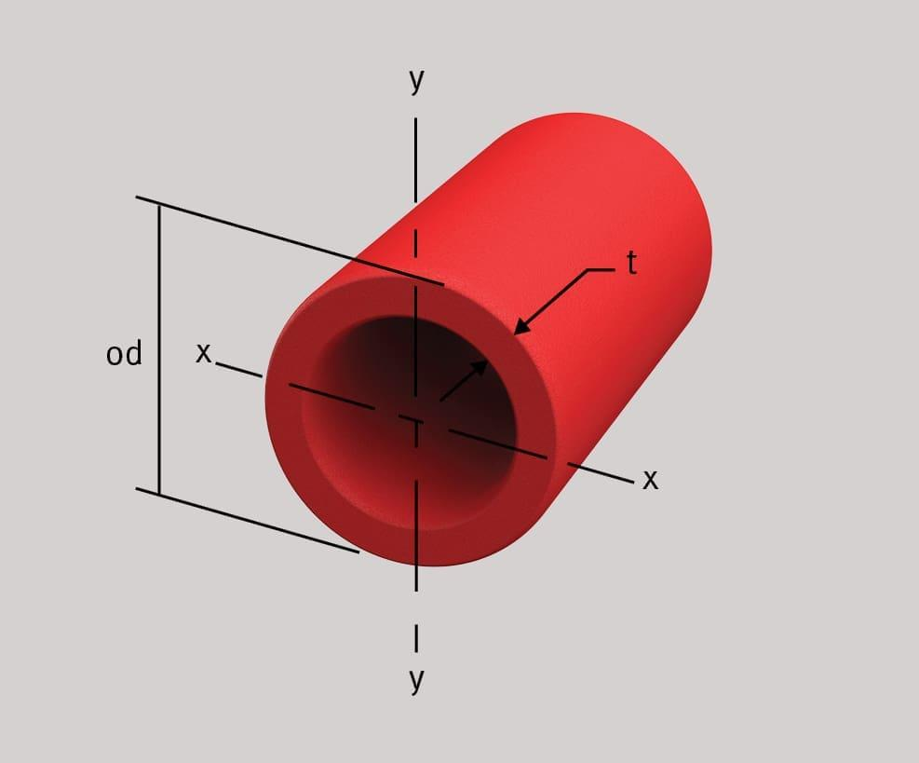
A hollow pipe produces an annular cross section when cut perpendicular to its length.
This section represents the material forming the pipe wall, excluding the hollow interior.

Cylindrical Shell
# Source: AI Source: Provided by: [Data Path: Persons Table -> ID Column: 1, Name_En Column: Motasem Essam] -> From: [ChatGPT] on [7/25/2026]
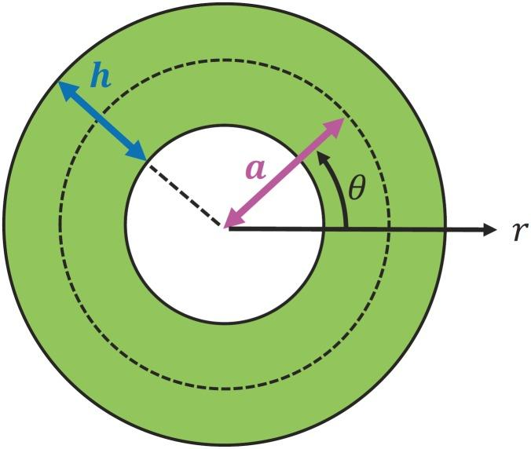
A cylindrical shell is the region between two coaxial cylindrical surfaces.
A plane perpendicular to the common axis produces an annular cross section.

Mathematical Representation

Annulus Equation
# Source: AI Source: Provided by: [Data Path: Persons Table -> ID Column: 1, Name_En Column: Motasem Essam] -> From: [ChatGPT] on [7/25/2026]
For an annulus centered at the origin:
$$r^{2}≤x^{2}+y^{2}≤R^{2}$$
Where:
- $R$ = outer radius.
- $r$ = inner radius.
- $R>r$.
For a center located at $(h,k)$:
$$r^{2}≤(x-h)^{2}+(y-k)^{2}≤R^{2}$$

Annular Area
# Source: AI Source: Provided by: [Data Path: Persons Table -> ID Column: 1, Name_En Column: Motasem Essam] -> From: [ChatGPT] on [7/25/2026]
The annular area is the outer circle's area minus the inner circle's area.
$$A=πR^{2}-πr^{2}$$
Therefore:
$$\boxed{A=π(R^{2}-r^{2})}$$

Radial Thickness
# Source: AI Source: Provided by: [Data Path: Persons Table -> ID Column: 1, Name_En Column: Motasem Essam] -> From: [ChatGPT] on [7/25/2026]
$$t=R-r$$

Outer and Inner Circumferences
# Source: AI Source: Provided by: [Data Path: Persons Table -> ID Column: 1, Name_En Column: Motasem Essam] -> From: [ChatGPT] on [7/25/2026]
Outer circumference:
$$C_{\text{outer}}=2πR$$
Inner circumference:
$$C_{\text{inner}}=2πr$$
Total boundary length:
$$C_{\text{total}}=2π(R+r)$$

Annular Cross Section of a Hollow Cylinder
# Source: AI Source: Provided by: [Data Path: Persons Table -> ID Column: 1, Name_En Column: Motasem Essam] -> From: [ChatGPT] on [7/25/2026]
For a hollow cylinder with outer radius $R$, inner radius $r$, and height $h$:
$$V=π(R^{2}-r^{2})h$$
The volume is obtained by multiplying the annular cross-sectional area by the cylinder's height.

Annular Cross Section of a Ring Torus
# Source: AI Source: Provided by: [Data Path: Persons Table -> ID Column: 1, Name_En Column: Motasem Essam] -> From: [ChatGPT] on [7/25/2026]
For a ring torus with major radius $R$ and minor radius $r$, where $R>r$:
$$R_{\text{outer}}=R+r$$
$$R_{\text{inner}}=R-r$$
Its central horizontal annular section has area:
$$A=π[(R+r)^{2}-(R-r)^{2}]$$
Simplifying:
$$\boxed{A=4πRr}$$
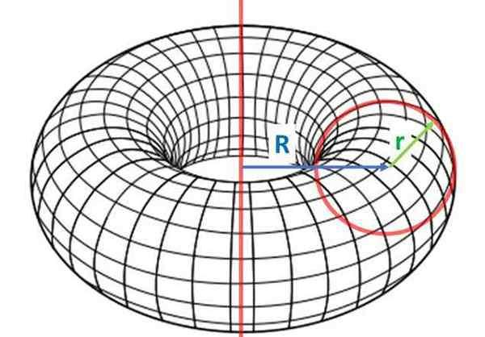

Annular Cross Section at Different Torus Heights
# Source: AI Source: Provided by: [Data Path: Persons Table -> ID Column: 1, Name_En Column: Motasem Essam] -> From: [ChatGPT] on [7/25/2026]
For a ring torus centered at the origin, let $z$ be the height of a horizontal cutting plane.
The radius of the tube's circular cross section at that height is:
$$q=\sqrt{r^{2}-z^{2}}$$
For $|z|<r$, the annular section has:
$$R_{\text{outer}}=R+q$$
$$R_{\text{inner}}=R-q$$
Its area is:
$$A(z)=π[(R+q)^{2}-(R-q)^{2}]$$
Therefore:
$$\boxed{A(z)=4πR\sqrt{r^{2}-z^{2}}}$$
This applies to horizontal sections through the interior of a standard ring torus. At $z=0$, the annulus is widest; as the plane approaches the top or bottom of the torus, the section approaches a single circle.

Mathematical Properties
# Source: AI Source: Provided by: [Data Path: Persons Table -> ID Column: 1, Name_En Column: Motasem Essam] -> From: [ChatGPT] on [7/25/2026]
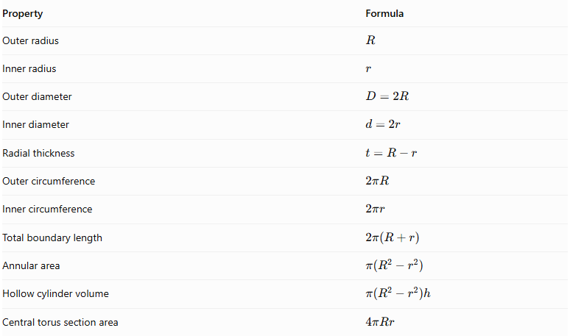
Property | Formula
Outer radius | $$R$$
Inner radius | $$r$$
Outer diameter | $$D=2R$$
Inner diameter | $$d=2r$$
Radial thickness | $$t=R-r$$
Outer circumference | $$2πR$$
Inner circumference | $$2πr$$
Total boundary length | $$2π(R+r)$$
Annular area | $$π(R^{2}-r^{2})$$
Hollow cylinder volume | $$π(R^{2}-r^{2})h$$
Central torus section area | $$4πRr$$

Annular Cross Section vs. Other Cross-Section Shapes
# Source: AI Source: Provided by: [Data Path: Persons Table -> ID Column: 1, Name_En Column: Motasem Essam] -> From: [ChatGPT] on [7/25/2026]
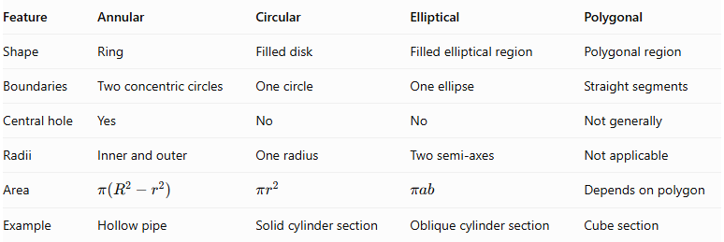
Feature | Annular | Circular | Elliptical | Polygonal
Shape | Ring | Filled disk | Filled elliptical region | Polygonal region
Boundaries | Two concentric circles | One circle | One ellipse | Straight segments
Central hole | Yes | No | No | Not generally
Radii | Inner and outer | One radius | Two semi-axes | Not applicable
Area | $$π(R^{2}-r^{2})$$ | $$πr^{2}$$ | $$πab$$ | Depends on polygon
Example | Hollow pipe | Solid cylinder section | Oblique cylinder section | Cube section

Applications
# Source: AI Source: Provided by: [Data Path: Persons Table -> ID Column: 1, Name_En Column: Motasem Essam] -> From: [ChatGPT] on [7/25/2026]
- Mechanical Engineering: Calculating the material area of hollow shafts, sleeves, and cylindrical components.
- Pipelines: Determining the wall area of hollow pipes and tubes.
- Construction: Analyzing hollow structural columns and cylindrical supports.
- Manufacturing: Calculating material quantities for washers, rings, and cylindrical shells.
- Fluid Engineering: Studying the geometry of pipes and hollow conduits.
- Mathematics: Calculating areas and volumes using annular cross sections.
- Architecture: Designing circular ring-shaped structural components.

Main Classification
# Source: AI Source: Provided by: [Data Path: Persons Table -> ID Column: 1, Name_En Column: Motasem Essam] -> From: [ChatGPT] on [7/25/2026]
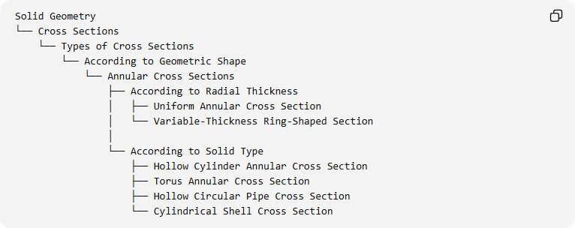
Solid Geometry
└── Cross Sections
└── Types of Cross Sections
└── According to Geometric Shape
└── Annular Cross Sections
├── According to Radial Thickness
│ ├── Uniform Annular Cross Section
│ └── Variable-Thickness Ring-Shaped Section
│
└── According to Solid Type
├── Hollow Cylinder Annular Cross Section
├── Torus Annular Cross Section
├── Hollow Circular Pipe Cross Section
└── Cylindrical Shell Cross Section
The variable-thickness ring-shaped section is a related generalization, not a strict annulus bounded by concentric circles.

Key Points
# Source: AI Source: Provided by: [Data Path: Persons Table -> ID Column: 1, Name_En Column: Motasem Essam] -> From: [ChatGPT] on [7/25/2026]
- An annular cross section is a ring-shaped region bounded by two concentric circles.
- It has an outer radius and an inner radius.
- The central hole is excluded from the annular area.
- Its area is calculated using $A=π(R^{2}-r^{2})$.
- Hollow cylinders and pipes produce annular sections when cut perpendicular to their axes.
- A ring torus produces an annular section when cut through its central horizontal plane.
- The annular section of a torus changes as the horizontal cutting plane moves vertically.

Conclusion
# Source: AI Source: Provided by: [Data Path: Persons Table -> ID Column: 1, Name_En Column: Motasem Essam] -> From: [ChatGPT] on [7/25/2026]
Annular Cross Sections are ring-shaped two-dimensional regions formed by intersecting suitable three-dimensional solids with planes. They are characterized by two concentric circular boundaries, an outer radius, and an inner radius. They are especially important in the study of hollow cylinders, pipes, cylindrical shells, and ring toruses.

